**Higher-order effects and validity of the point-dipole approximation for conjugated extended molecular emitters near plasmonic nanostructures**

Colin Van Dyck,a Mhamad Hantro, a Bjorn Maes,b and Gilles Rosolenb

*a* *University of Mons, Theoretical Chemical Physics group, Research Institute for Materials Science and Engineering Place du Parc 20, Mons, Belgium*

*b* *University of Mons, Micro- and Nanophotonic Materials Group, Research Institute for Materials Science and Engineering, Place du Parc 21, Mons, Belgium*

Abstract:

Recent experiments showed that light emission from a molecule can be triggered by inelastic electron tunnelling through a molecular device. The electronic current promotes the molecule in an excited state, and further deexcitation process leads to photon emission.1 Very interestingly, the metallic tip is a plasmonic nanostructure. Those specific environments are known to strongly enhance the light emission rate, which is named as the Purcell effect in literature. This strong enhancement effect enables optical detection of single molecule fluorescence or the well-known surface-enhancement effect in Raman spectroscopy.2

Light emission from a molecule is usually approximated as being emitted from an oscillating point-dipole, with the transition dipole moment as a key-property. This approximation generally prevails in the characterization of light emission from molecules, in various environments such as solution but also near plasmonic structures. More recently, it has been suggested that plasmonic nanostructures may confine light to effective wavelengths within the sub-molecular scale.3 Consequently, the question of whether the standard description of a molecular emitter as a point-dipole, i.e., the unique consideration of the transition dipole moment, remains a reasonable assumption.

In this presentation, we introduce a theoretical framework to explore the limits of this standard description. It allows us to calculate the fluorescence emission rate of a quantum emitter, described at the TD-DFT level, within a nanoplasmonic environment, described by solving Maxwell equations. It is used to characterize the emission rate of different conjugated emitters : (i) an H2Pc molecule within an STM tip-substrate nanogap and (ii) oligothiophenes of different chain lengths (0.8, 1.6 and 2.4 nm) near gold nanospheres. Significant deviations from the point-dipole approximation are predicted for those elementary structures and environments. This result is due to complex high-order multipolar effects. Consequently, the usual description of a molecule using the transition dipole moment breaks down. This paves the way toward high-order photochemistry, with, for example, the activation of dipole-forbidden transitions revealing usually dark spectroscopic features.1

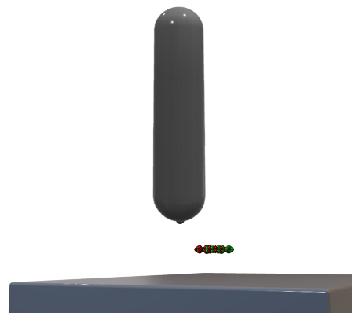

*H2Pc molecular emitter lying on a substrate and optically coupled to a plasmonic STM tip*

References:

1 S. Jiang, et al, Science **379**(6636), 1049–1054 (2023).

2 G. Sun, et al, Phys. Rev. A **85**(6), 063410 (2012).

3 N. Rivera, et al, Science **353**(6296), 263–269 (2016).