**New Strategies for Functional Devices Through Ultrathin Molecular Layers**

Rui LI,a Jean-Christophe LACROIX,a Pascal MARTIN.a

*a ITODYS, UMR7086, CNRS 15 rue Jean Antoine de Baïf, 75013 Paris, France.*

*Email: rui.li2@etu.u-paris.fr*

Abstract:

Molecular Electronics (MEs) are driven by the dream of expanding Moore’s law to the molecular level for next-generation electronics by incorporating molecules into electronic circuits. Compared to traditional silicon-based electronic devices, MEs offer unparalleled advantages, such as faster performance, higher packing density, and exceptional functional diversity. As one of the essential components of MEs, Molecular Junctions (MJs) comprising a single molecule or an assembly of many molecules between two conducting electrodes, have garnered substantial research interest.

In this study, ultrathin layers (7-10nm) of 4,4’-diamino-2,2’-stilbenedisulfonic acid (DAS) oligomers were grafted on gold strip electrodes by electrochemical reduction of in-situ generated diazonium salts (**Figure 1**. a) 1. Then, a Ti/Au top contact was deposited to complete a solid-state MJ2. These fabricated devices exhibit robust and reproducible rectification, with the current at +2 V (positive bias on the gold strip electrode) exceeding that at -2 V by more than 2000 times (**Figure 1**. b).

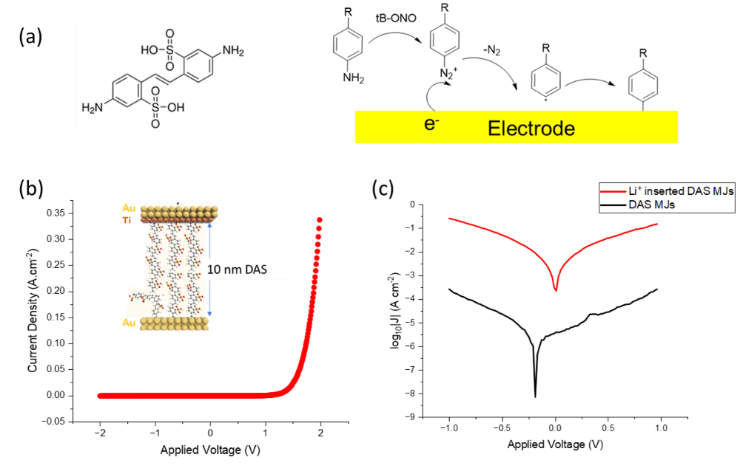Furthermore, to investigate the role counterions play in the conductivity of DAS-basted MJs, Li+ ions were incorporated into DAS layers through ion exchange. Compared to parallelly fabricated DAS-based MJs, Li⁺-inserted DAS MJs exhibit a remarkable 1000-fold increase in current, with a current density of 0.2 A/cm2 at 1V (**Figure 1**. c).

***Figure 1****. (a)* *Schematic representation of DAS and its electrochemical grafting through diazonium salt reduction on a gold electrode. (b) Average current-density vs applied voltage (JV) curves of Au/DAS/Ti/Au MJs. Inset: Schematic illustration of a molecular junction. (c) Logarithmic plots (log₁₀|J|) of current density vs. voltage for DAS MJs and Li⁺-inserted DAS MJs.*

References:

(1) Philippe, A. *J. Am. Chem. Soc.* 1997, 119, 1, 201–207.

(2) Nguyen, Q. *J. Am. Chem. Soc.* 2017, 139 (34), 11913–11922.